

Call for Abstracts
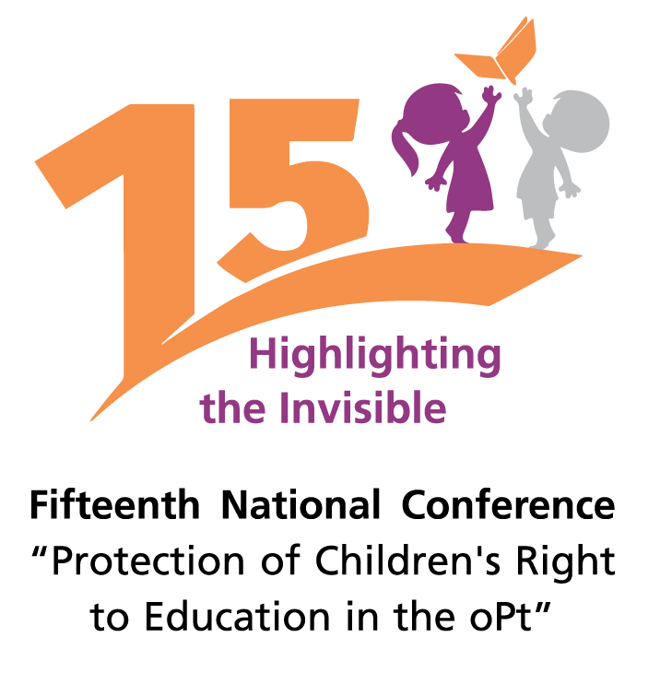

Ramallah – November 2019

On the occasion of the 30th anniversary of the signing of the Convention on the Rights of the Child (CRC) by the United Nations in 1989 and the fifth anniversary of the accession of the State of Palestine to the Convention as well as a number of human rights conventions and treaties, Defence for Children International – Palestine Section, in cooperation with the Ministry of Education, Ministry of Foreign Affairs, Ministry of Social Development and Al-Quds University, is organising a two-day national conference (with international participation) on 20 and 21 November 2019 in Ramallah on "Protection of Children's Right to Education in oPt" entitled "Highlighting the Invisible." The Conference is funded by Save the Children.

The organisers of the conference, therefore, call upon all interested academics, professionals, and jurists to submit their papers on the following themes:

- The role of the State in providing and ensuring a safe, supportive and stimulating educational environment.
- Institutional interventions (Palestinian civil society organisations and international organisations) that help protect the right to education under occupation.
- The role of reports and information in determining responsibilities, obligations and accountability for violations of the right to education.
- The participation of children as human rights defenders.
- The Sustainable development goals and the right to education.
- International Law and protection of the right to education (international complaints and protection mechanisms).
- International experiences in protecting the right to education and participation.

Those interested in participating should submit their abstracts by 15 September 2019, whereas the papers accepted must be submitted to the Conference by 25 October 2019. Please note the following:

  - Abstracts should not exceed one page with a total of 300 words, in Arabic or English.
  - For Arabic abstracts, use Font Size 12, Font Type Arabic Transparent and 1.5line spacing. As for English abstracts, use Font Size 11, Font Type Times New Roman and 1.5line spacing.
  - The researcher should identify the main theme of the paper.
  - The paper should be directly related to the conference’s theme and its related topics.
  - Include name, address, email, and field of activity of the researcher.
  - Each researcher will be given 15 minutes to present their papers in the Conference.
  - All papers will be reviewed and evaluated by a specialised and academic committee.

Papers must be sent to conference15th@dcips.org

Defence for Children International
Ramallah – Palestine

State of Palestine

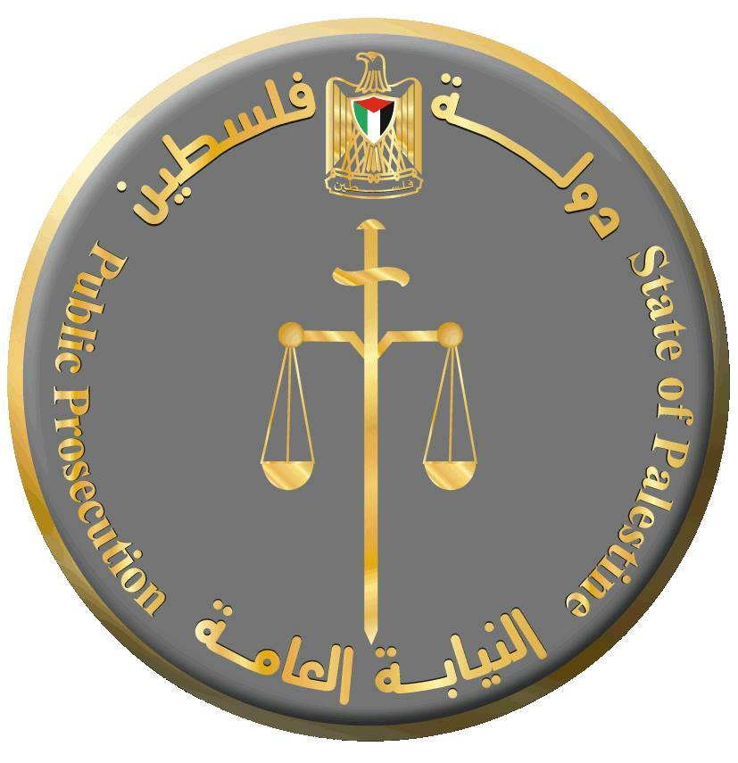
Al-Quds University | Public Prosecution | The Ministry Foreign Affairs | The Ministry Of Social Development | The Ministry Of Education

